**Q1 Write a programe to use mathematical operator**

**Source code:**

a=int(input("Enter the first number:"))

b=int(input("Enter the second number:"))

c=a+b

d=a-b

e=a*b

f=a/10

print("sum of two number is:",c)

print("subtraction of two number is:",d)

print("Multiply of two number is:",e)

print("Division of two number is:",f)

**output-**

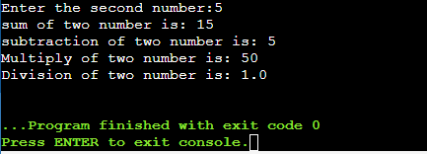

**Q2 -write a programe to take an input from the user and print the fibonacci serise**

**Source code:**

a=int(input("Enter the terminal number:"))

n1=0

n2=1

print("\n",n1,n2)

for i in range(2,a):

n3=n1+n2

print(n3," ",end="")

n1=n2

n2=n3

**output-**

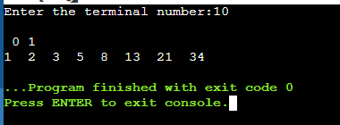

**Q3 write a programe to find a factorail of a number**

**Source code:**

def fact(a):

return 1 if(a==1 or a==0) else a* fact(a-1)

a=int(input("Enter a nmber:"))

print("factorial of number is:",fact(a))

**output-**

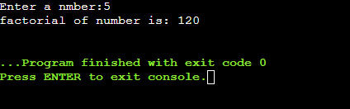

**Q4 write a programe to demostrate the use of nested if statement**

**Source code:**

num=int(input("Enter a value of number:"))

if num>=0:

if num==0:

print("zero")

else:

print("positive number**"**)

else:

print("Negative number")

output-

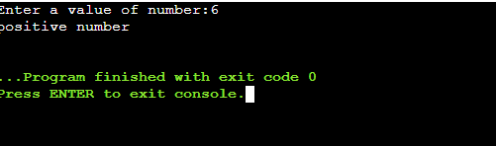

**Q5-write a programe to demostrate a if and else block**

**Source code:**

age=int(input("Enter the age:"))

if age<18:

print("you are not eligible to vote")

else:

print("you are eligible to vote")

**output-**

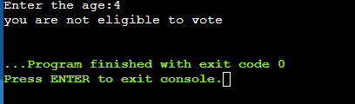

**Q6-wite a programe to demostrate a python module**

**Source code:**

import math

print("The value of pi is", math.pi)

output-

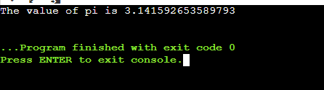

**Q7-write a progrme for searching an element and sorting a list**

**Source code:**

def search(list,n):

for i in range(len(list)):

if list[i] == n:

return True

return False

list = [5,8,2,1,7]

n = 8

if search(list, n):

print("Found")

else:

print("Not Found")

list.sort()

print("sorted list is:\n")

print(list)

output-

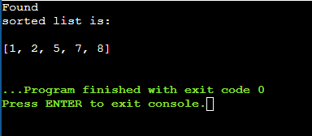

**Q8-write a programe to check whether a number is prime number or not using loops**

**Source code:**

print("Enter a number")

num = int(input())

y = []

if num > 1:

for i in range(2,num):

x = num % i

y.append(x)

if 0 in y:

print(" not a prime number")

else:

print("prime number")

else:

print("not a prime number")

**output-**

